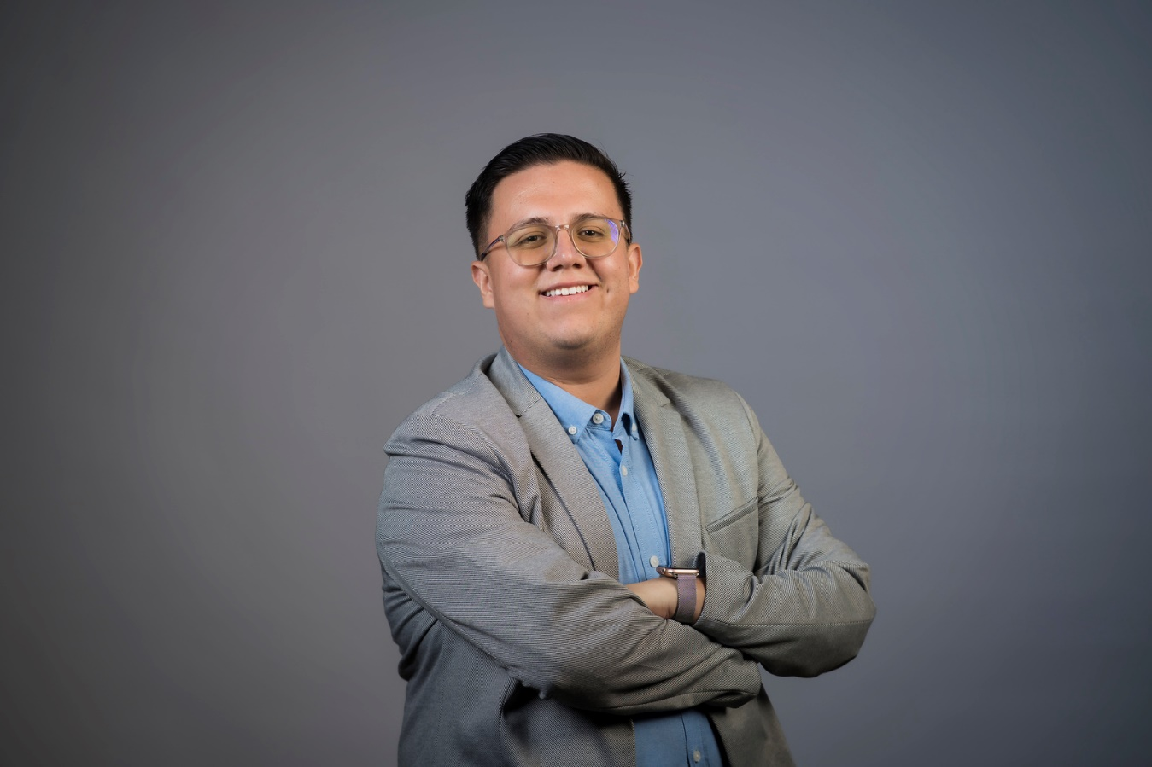

Full Name: Carlos Camacho Valverde

Google Scholar link: <https://scholar.google.com/citations?hl=es&user=r5iEZxEAAAAJ>

Linkedin link: <https://cr.linkedin.com/in/carlos-camacho-valverde-5851b4110>

Email: [clcamacho@ufidelitas.ac.cr](mailto:clcamacho@ufidelitas.ac.cr)

Area of Expertise: Software Engineering and Databases.

Faculty: Computer Science

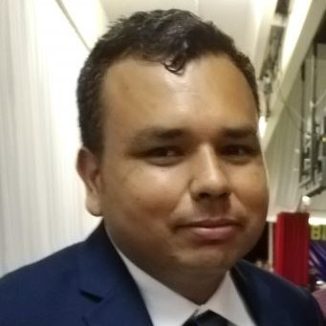

Full Name: Emmanuel  Alberto Coto Roque

Google Scholar link: NA

Linkedin link: [www.linkedin.com/in/emmanuel-alberto-c-34167b11b](http://www.linkedin.com/in/emmanuel-alberto-c-34167b11b)

Email: [ecoto@ufidelitas.ac.cr](mailto:ecoto@ufidelitas.ac.cr)

Area of Expertise: Materials Processing And mechanical design

Faculty:  Electrical engineering and related

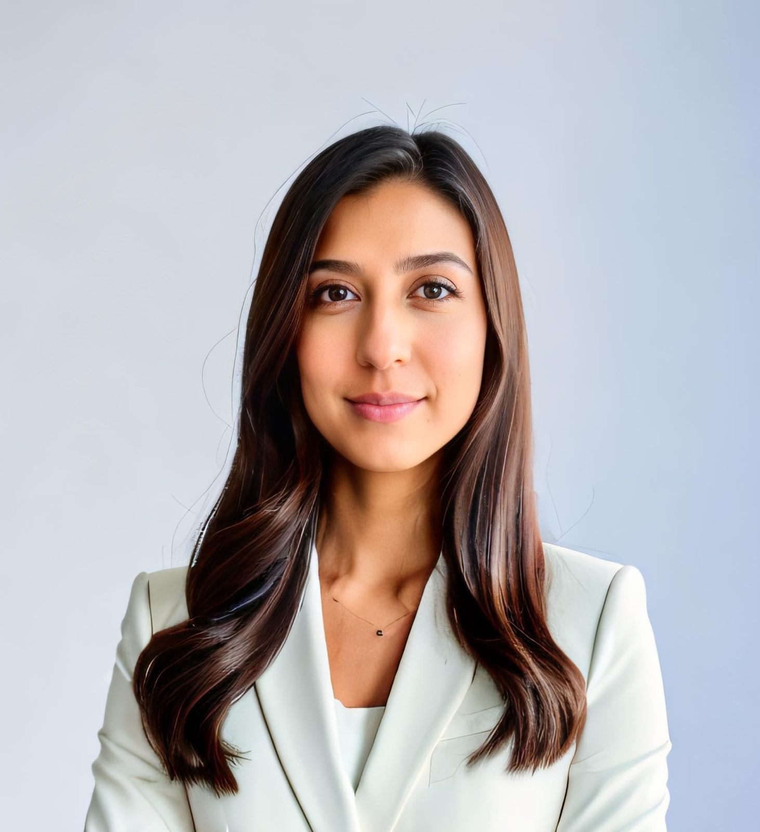

Full Name: Alejandra Baldi Sevilla

Google Scholar link: <https://scholar.google.com/citations?user=ZiaVoy8AAAAJ&hl=es&oi=ao>

Linkedin link: <https://www.linkedin.com/in/alejandra-baldi-sevilla-78239b4a/?originalSubdomain=cr>

Email: [abaldi@ufidelitas.ac.cr](mailto:abaldi@ufidelitas.ac.cr)

Area of Expertise: chemistry of materials, pavement materials, sustainability

Faculty: Civil Engineering

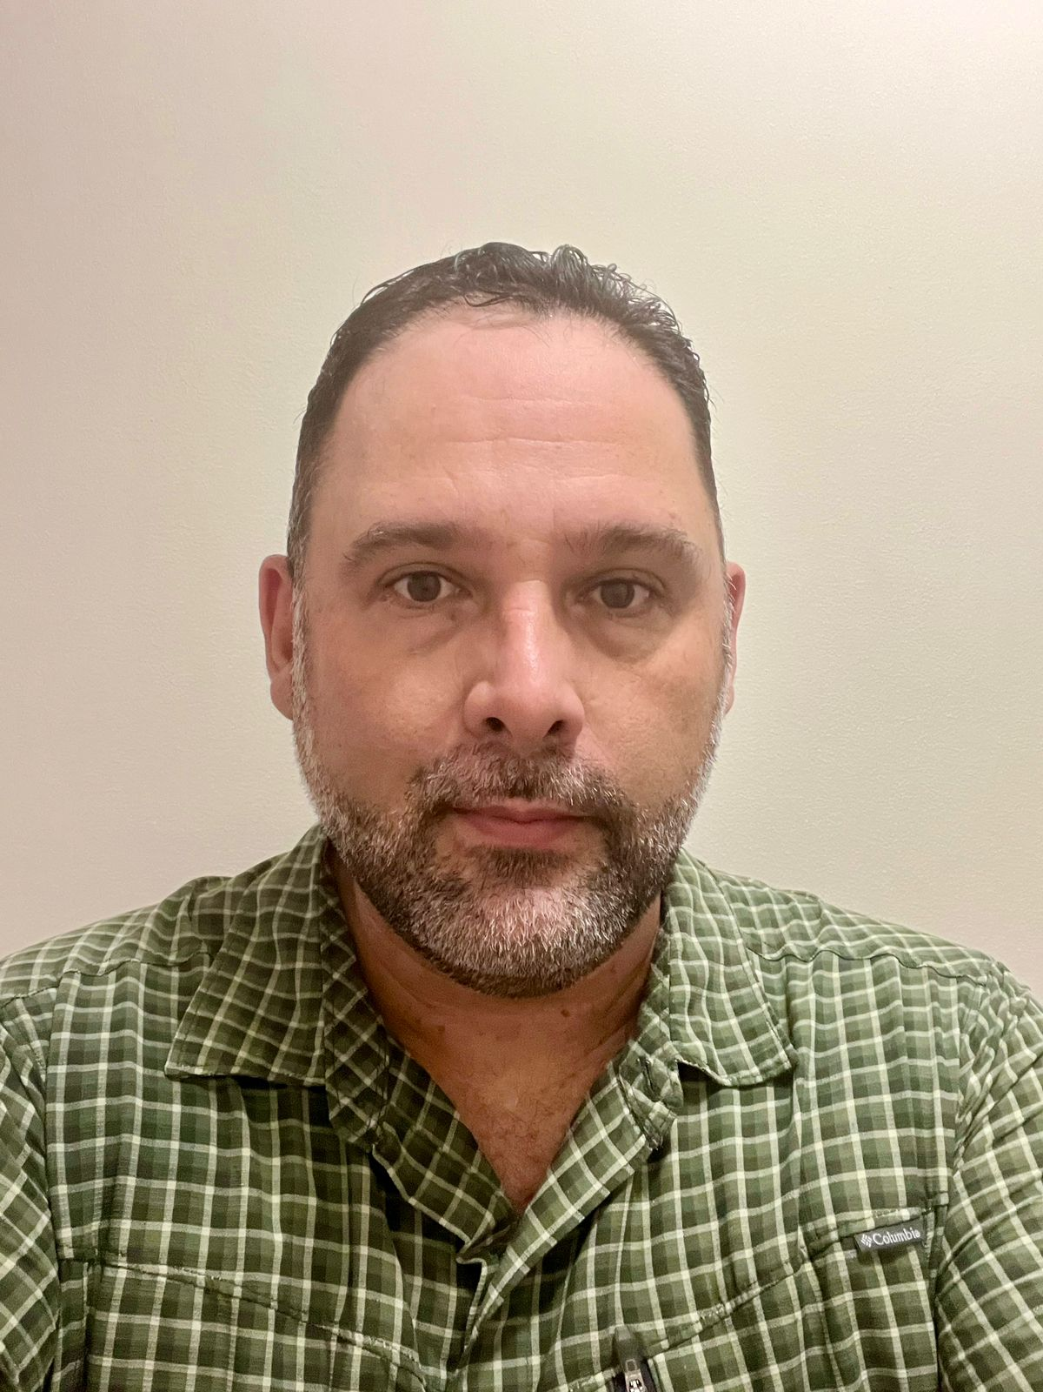

Full Name: Goering Carballo Rodríguez

Google Scholar link: NA

Linkedin link: [www.linkedin.com/in/goering-carballo-19999615](http://www.linkedin.com/in/goering-carballo-19999615)

Email: [gcarballo@ufidelitas.ac.cr](mailto:gcarballo@ufidelitas.ac.cr)

Area of Expertise: Concrete Technology

Faculty: Civil Engineering

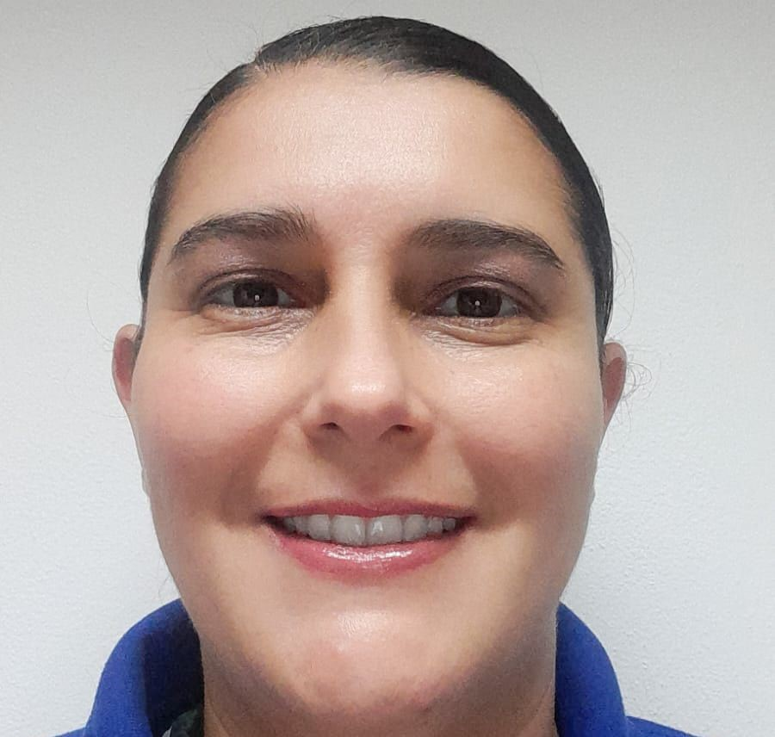

Full Name: Jacqueline Flores Marin

Google Scholar link: N/A

Linkedin link: <https://www.linkedin.com/in/jacqueline-flores-marin-58131720/?originalSubdomain=cr>

Email: [jflores90994@ufide.ac.cr](mailto:jflores90994@ufide.ac.cr)

Area of Expertise: Management skills, process management, standardization

Faculty: Industrial Engineering

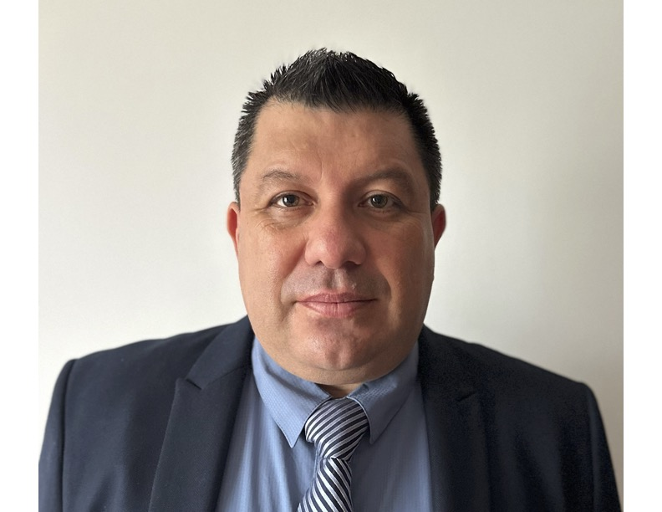

Full Name: Alexander Molina Villalobos.

Google Scholar link. NA

Linkedin link. NA

Email: [alexander.molinav@ufide.ac.cr](mailto:alexander.molinav@ufide.ac.cr)

Area of Expertise: Geotechnical Engineering

Faculty: Civil Engineering

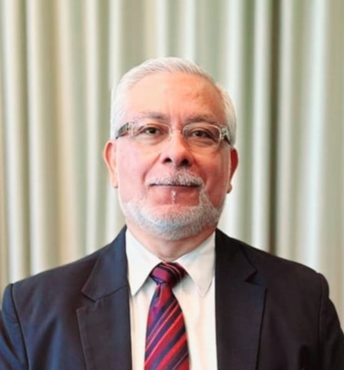

Full Name: Gonzalo Ernesto Meza Rivera

Google Scholar link: N.A.

Linkedin link: www.linkedin.com/in/gonzaloernestomezarivera

Email: gmeza@ufidelitas.ac.cr

Area of Expertise: Academic Quality/New Technologies and Digital skills

Faculty: Academic Quality Department.

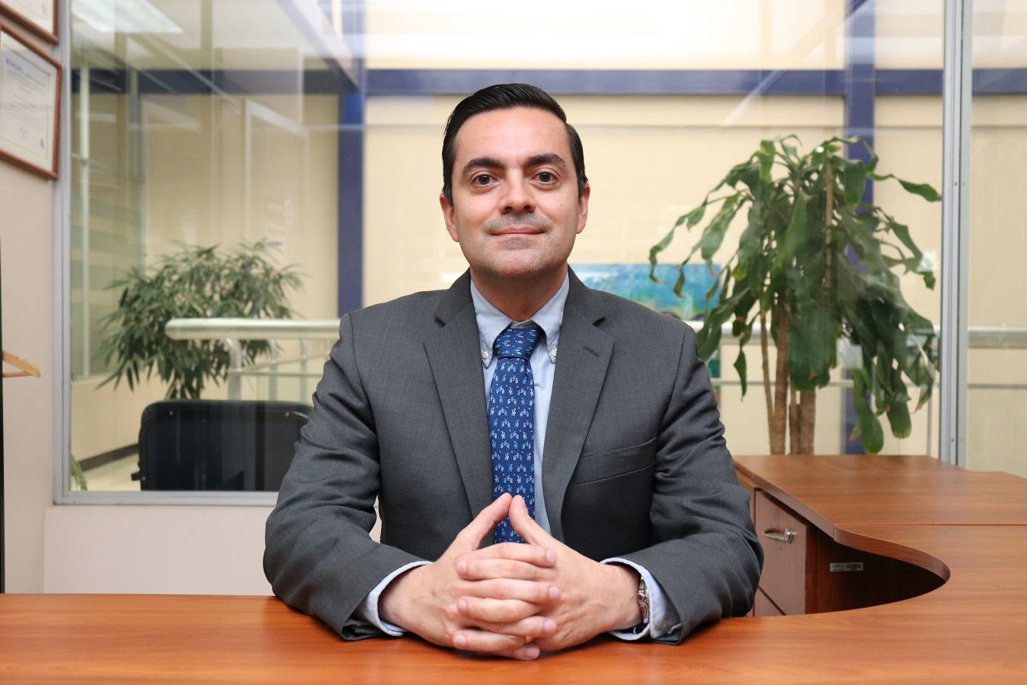

Full Name: José Pablo Aguiar Moya

Google Scholar link: https://scholar.google.com/citations?hl=en&authuser=2&user=TyTnR7sAAAAJ

Linkedin link: https://www.linkedin.com/in/josé-pablo-aguiar-moya/

Email: jaguiar@ufidelitas.ac.cr

Area of Expertise: Transportation Engineering, Material Science, Pavements

Faculty: Civil Engineering

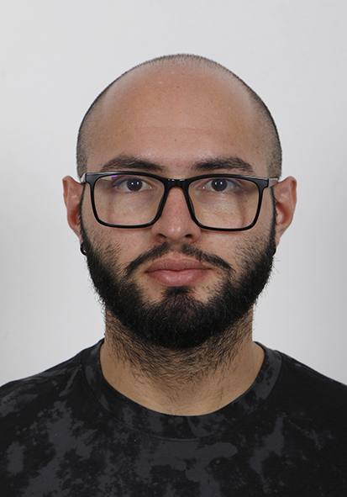

Full Name: Jose Pablo Castro Arias

Google Scholar link: NA

Linkedin link: https://www.linkedin.com/in/jose-pablo-castro-arias-8626a3174

Email: jcastro40224@ufide.ac.cr

Area of Expertise: Physics

Faculty: Basic Sciences

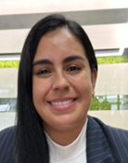

Full Name: Natalie Leitón Sancho

Google Scholar link: N/A

Linkedin link: [www.linkedin.com/in/nathalie-leitón-sancho-318b38309](http://www.linkedin.com/in/nathalie-leitón-sancho-318b38309)

Email: [nleiton@ufidelitas.ac.cr](mailto:nleiton@ufidelitas.ac.cr)

Area of Expertise: industrial engineering / math

Faculty: industrial engineering

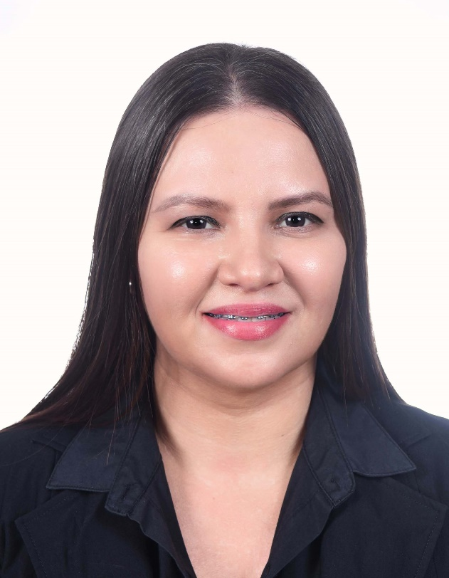

Full Name: Christy Saires Aguero V

Google Scholar link: N/A

Linkedin link: [linkedin.com/in/khristy-aguero-65a41564](https://www.linkedin.com/in/khristy-aguero-65a41564?lipi=urn%3Ali%3Apage%3Ad_flagship3_profile_view_base_contact_details%3BOPwQPJMWTDmHuOQbWqXA3Q%3D%3D)

Email: [christy@ufidelitas.ac.cr](mailto:christy@ufidelitas.ac.cr)

Area of Expertise: Computer systems

Faculty:Computer Systems Engineering